Pointer:

Q. what is pointer?
Pointer is a derived data type which is used for allocate memory dynamically or
Perform dynamic memory allocation.

Q. what is derived data type?
__________________________________________________
Derived data type means those data type acquire property from another data type and can complete its meaning called as derived data type.

Q. what is dynamic memory allocation?
_______________________________________________________________
Dynamic memory allocation means we can decide how much memory required at program
run time called as dynamic memory allocation.

Q. How to use pointer practically in programming?
if we want to use pointer practically we have following syntax

datatype *variablename;
Example: int *ptr;

Q. how to pointer allocate memory dynamically?
________________________________________________________________
Pointer can allocate memory dynamically with the help of memory address.

Q. what is memory address?
Memory address is unique integer number provided by ram to every memory block or
it may be hex number.
Q. Can we see the memory address?
Yes we can see the memory address and for that we have & operator

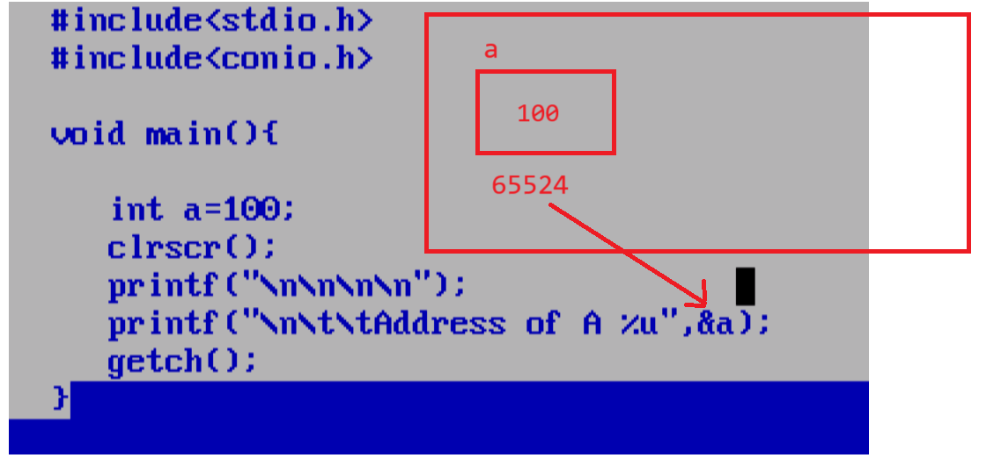
Note: if we want to allocate memory dynamically by using a pointer we have to
store address of another variable in pointer or allocate block at run time by using memory allocation function and store address in pointer.

How to store address of another variable in pointer
If we want to store address of another variable in pointer we have following syntax

Syntax:
datatype *pointervariablename;
pointervariablename=&normalvariable;

Example:
int a=100,*ptr;
ptr=&a; //we store address of variable a in pointer variable ptr.

important points related with pointer
1. pointer store address of another memory and pointer his own address
2. We can use value on address using pointer which is stored in pointer just we required to use
* with pointer (* technical meaning is value at address operator or indirection operator or dereferencing)
3. when we increase or decrease pointer without * then pointer shift on next block or previous block depend on operation means pointer create new block in memory at run time and block size is dependent on pointer data type.
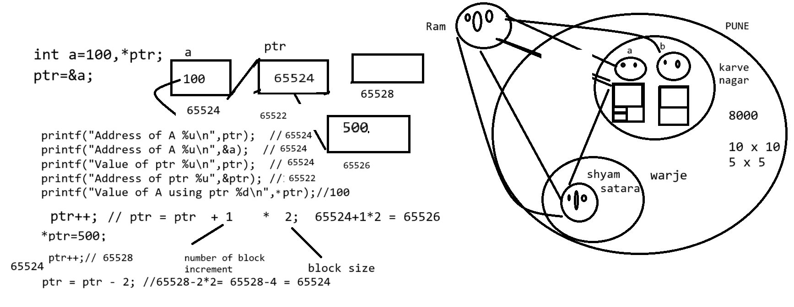
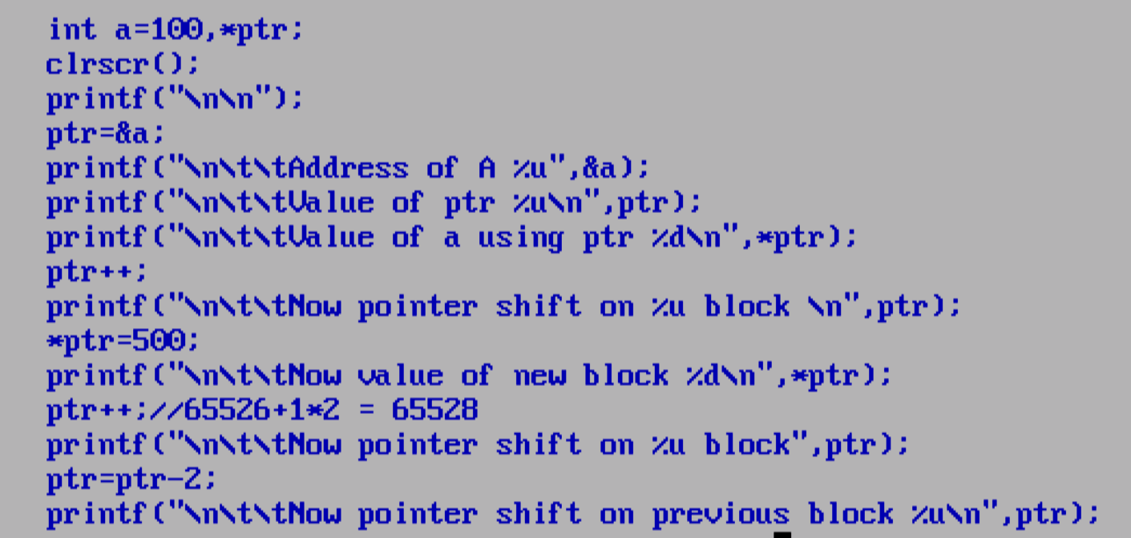

how to perform dynamic memory allocation?
____________________________________________________________________
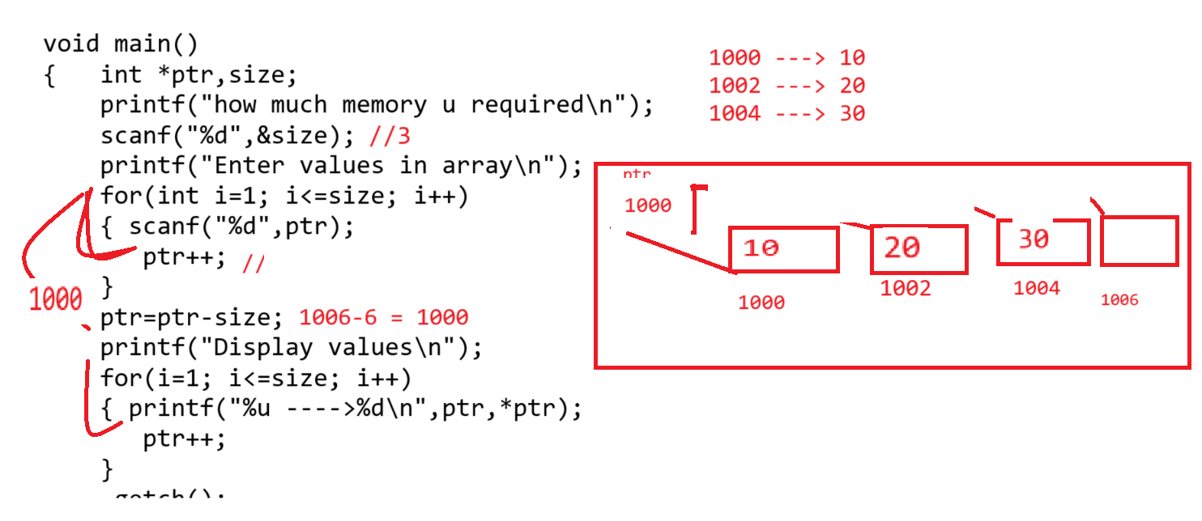

Source code
#include<stdio.h>
#include<conio.h>
void main()
{ clrscr();
int *ptr,size,i;
printf("\n\n");
printf("\nhow much memory u required\n");
scanf("%d",&size);
for(i=1;i<=size;i++)
{ printf("\nEnter value on %u block\n",ptr);
scanf("%d",ptr);
ptr++;
}
ptr=ptr-size;
printf("\nDisplay all values\n");
for(i=1; i<=size;i++)
{ printf("%u ---->%d\n",ptr,*ptr);
ptr++;
}
getch();
}

Applications of pointer
1. Can Access Array or Can allocate array at run time
2. Can Access String or allocate string run time
3. Pointer can work with function for maintain call by reference
4. Pointer can work with structure and union also

Types of Pointer
1. Generic pointer or void pointer
2. Dangling of pointer
3. Wild Card pointer
4. NULL Pointer
5. far pointer
6. huge pointer
7. near pointer
How to access array by using a pointer
____________________________________________________________________
If we want to access array by using a pointer we have to store base address of array in pointer variable.
Q. what is base address?
_______________________________________________________________________________
Base address is a 0th location address of array called as base address.

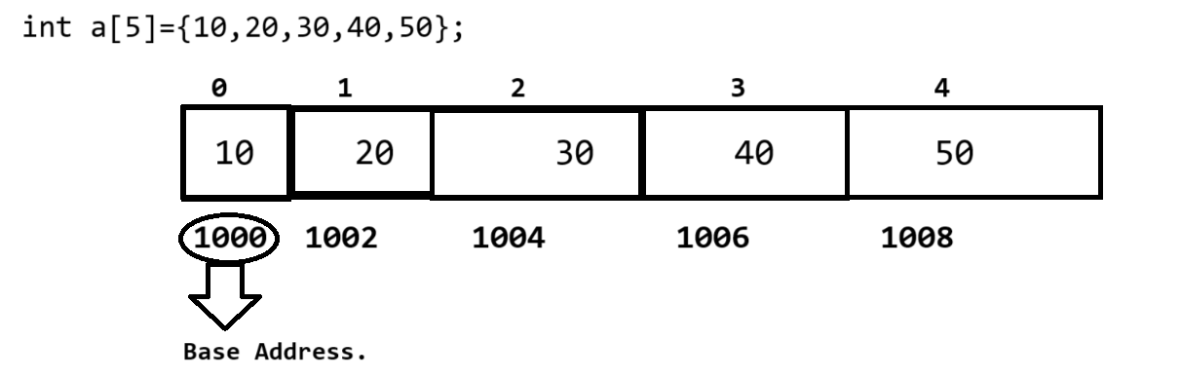
If we think here 1000 is your base address because it 0th location address.

Q. How to get base address?
_____________________________________________________________________
If we want to get base address of array we have two ways

1. Use array without subscript
2. Use array with &arrayname [0]

Example:
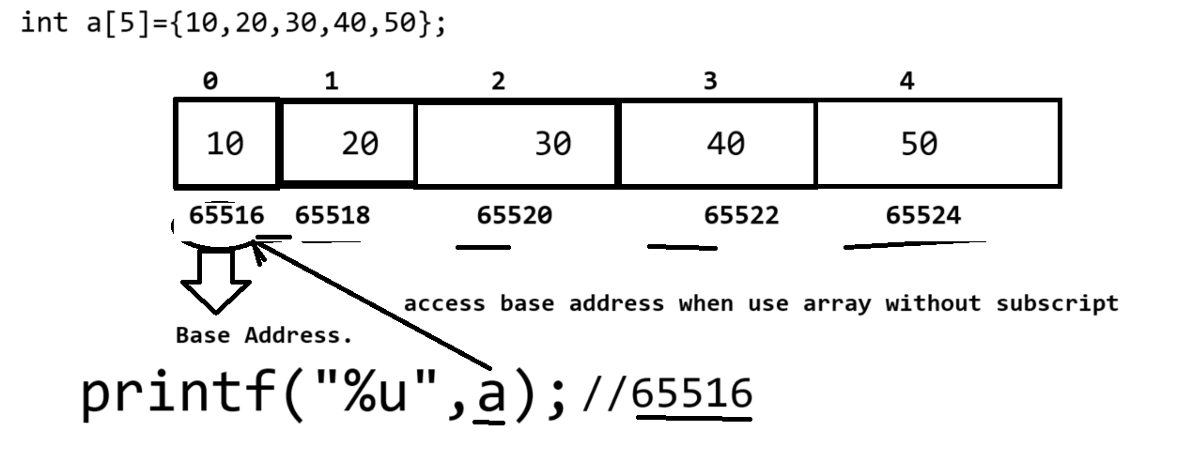

Access Array using a pointer
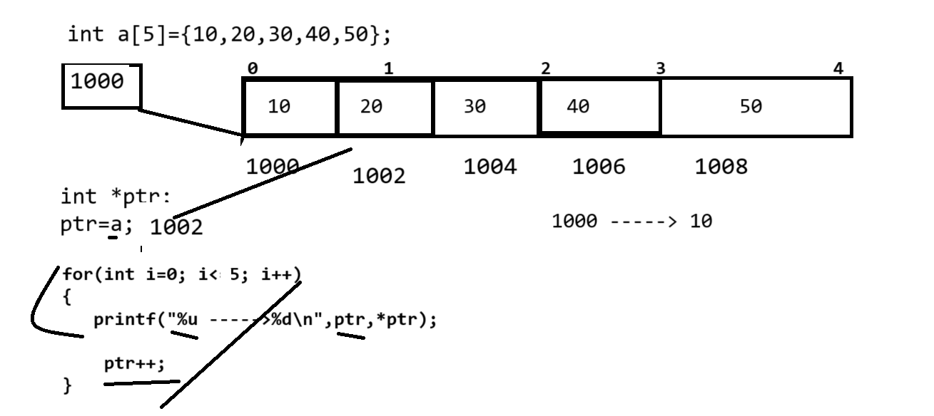

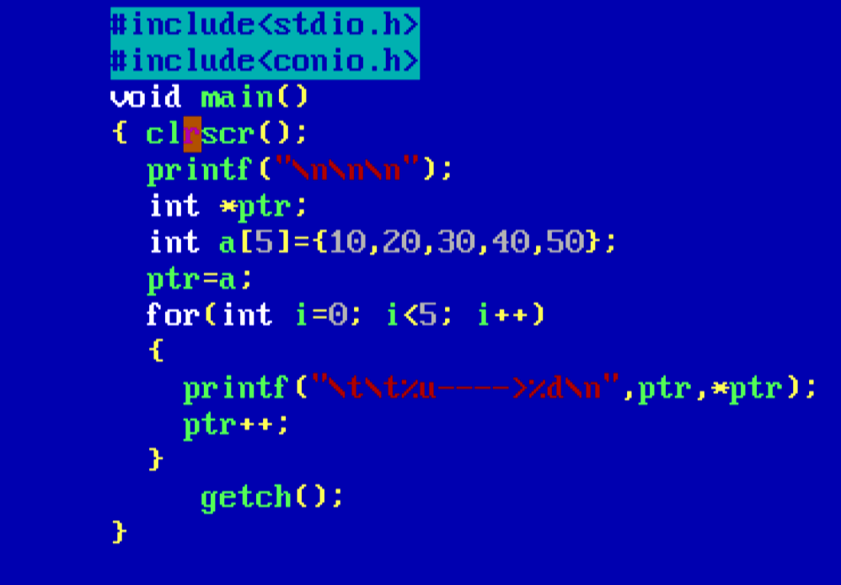

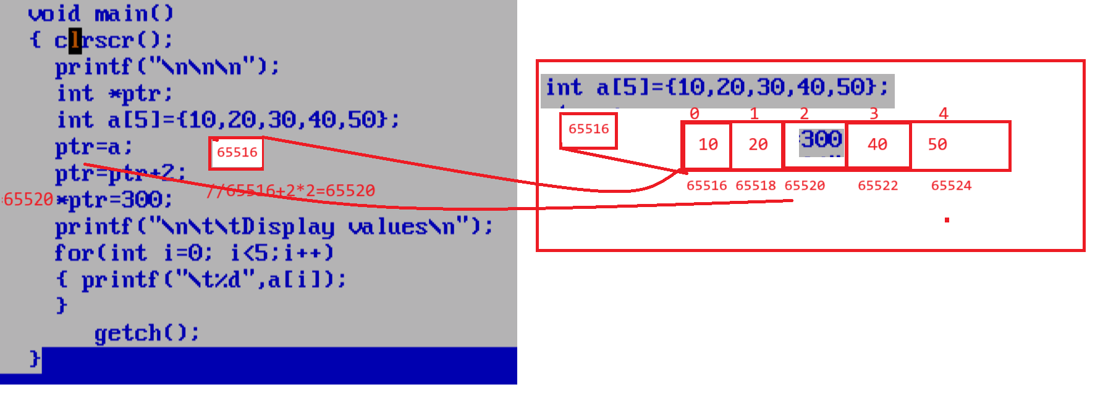
Q. what is meaning of a[i]?
_____________________________________________________________________
base address + index

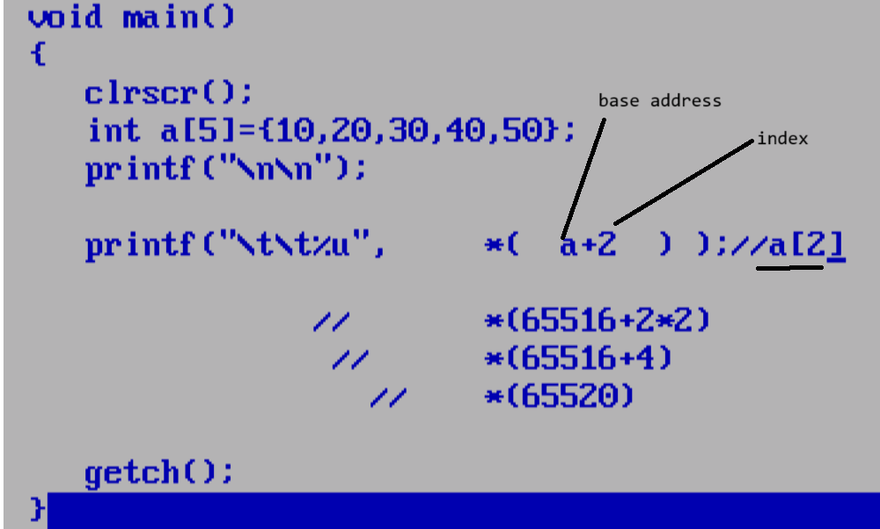

Example of base address+index internal working
#include<stdio.h>
#include<conio.h>
void main()
{ clrscr();
int a[5]={10,20,30,40,50};
printf("\n\n");
for(int i=0; i<5;i++)
{ printf("\t%u\t",*(&a[i]));//a[i]
}
//*(a+i)=*(i+a)=*(&a[i])=i[a]=a[i]=base address+index or index+base address
//a[i]=base address+index*size 65516+1*2
//i[a]=index*size+base address 1*2+65516
getch();
}

Example: what will be output of given code?
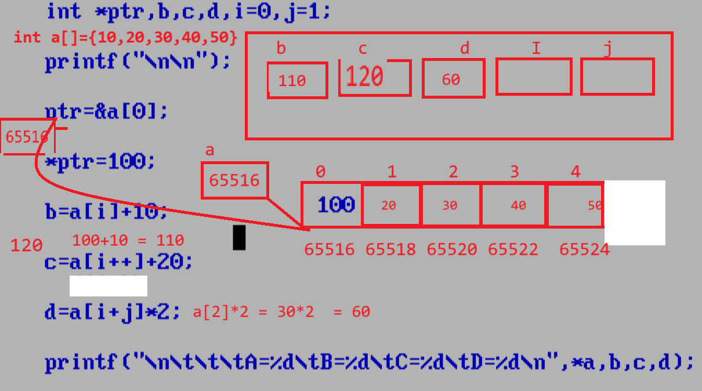
Q. what will be output of given code?
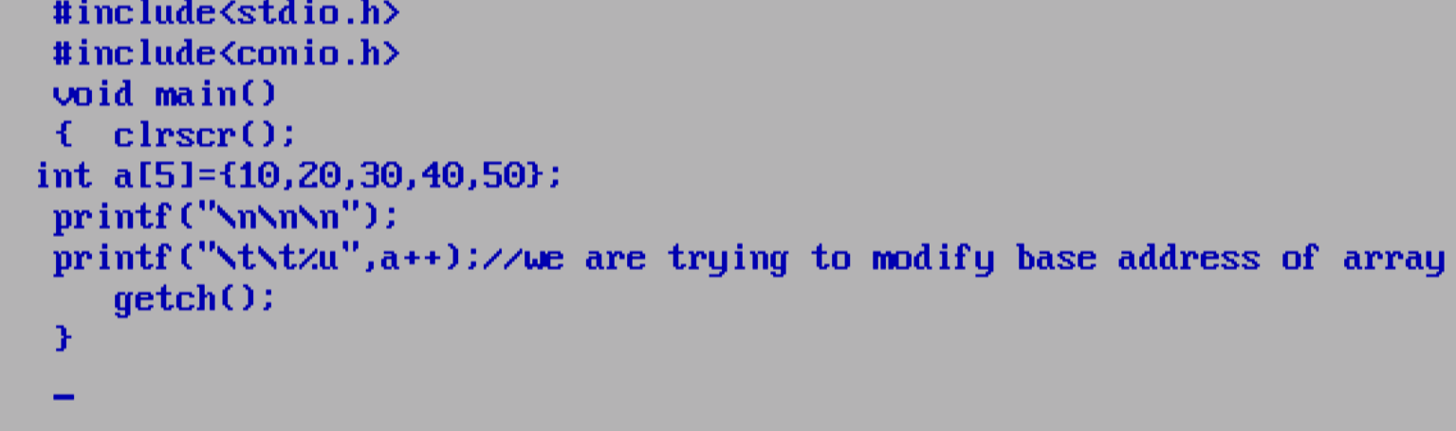
Note: above code generate compile time error to us because we are trying to modify the base
address of array and it is not possible.
//50% - 50%

Types of pointer
________________________________________________________________________________
1. Generic Pointer or types of pointer
_______________________________________________________________________________
Generic pointer means a void* pointer the major goal of void pointer is it works with any other type of address means using a void pointer we can store address of any type of data means it is common pointer and customize it as per your requirement.
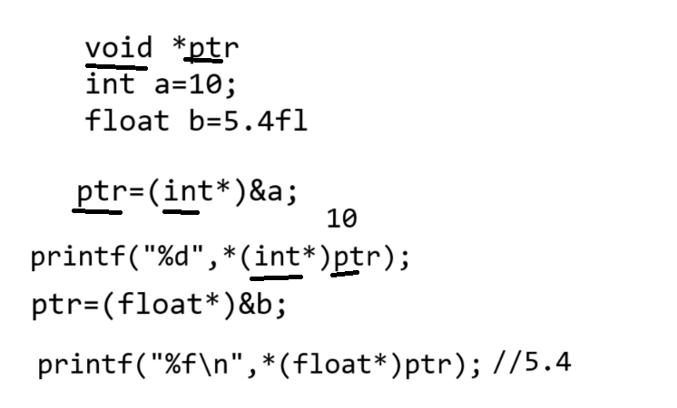

Dynamic Memory Allocation Function:
Dynamic memory allocation function is used for allocate memory at run time by using a pointer.

There are four dynamic memory allocation functions
1. Malloc: malloc is a dynamic memory allocation function it is used for allocate memory at program run time or it is used for allocate dynamic memory.
Syntax: pointer variable= (void*) malloc (size);

If we think about malloc function we have (void*) as return type means using malloc function we can allocate any type of memory just we need to convert in appropriate type and malloc function create only one block in memory of specified size.
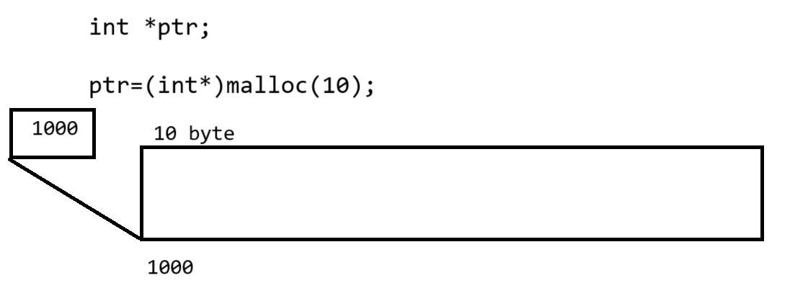

Note: you can use malloc for create dynamic array at run time using pointer.
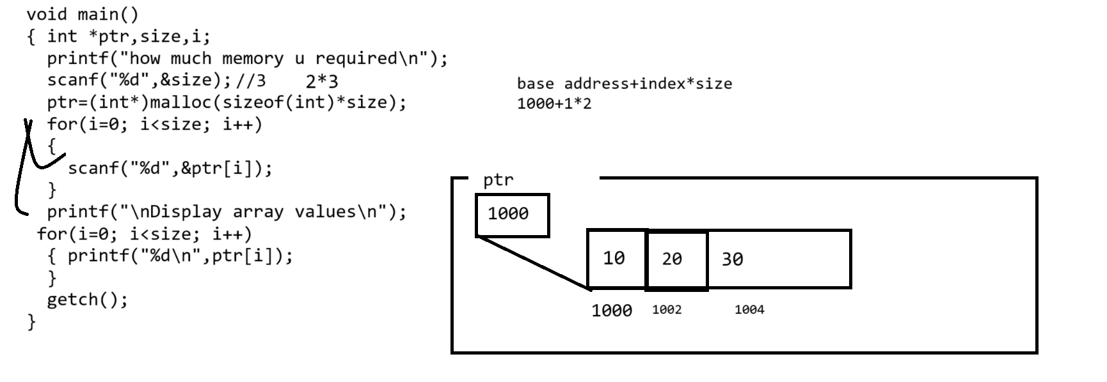

Source code

#include<stdio.h>
#include<conio.h>
#include<stdlib.h>
void main(){
clrscr();
int *ptr,size,i;
clrscr();
printf("\n\n\n");
printf("\n\t\tEnter size\n");
scanf("%d",&size);
ptr=(int*)malloc(sizeof(int)*size);
printf("\n\t\tEnter values in array\n");
for(i=0;i<size;i++)
{ scanf("%d",&ptr[i]);
}
printf("\n\t\tDisplay array values\n");
for(i=0;i<size;i++)
{ printf("\t\t%d\n",ptr[i]);
}
getch();
}

2. Realloc : realloc function help us to reallocate memory allocated by malloc function means some time if we want to expand memory at run time allocated by malloc or shrink memory at run time allocated by malloc then we can use realloc function
If we use malloc function then we allocate new memory every time but using a realloc we customize the memory allocate by malloc at run time

syntax: pointer = (void*)realloc(ptr,newsize)
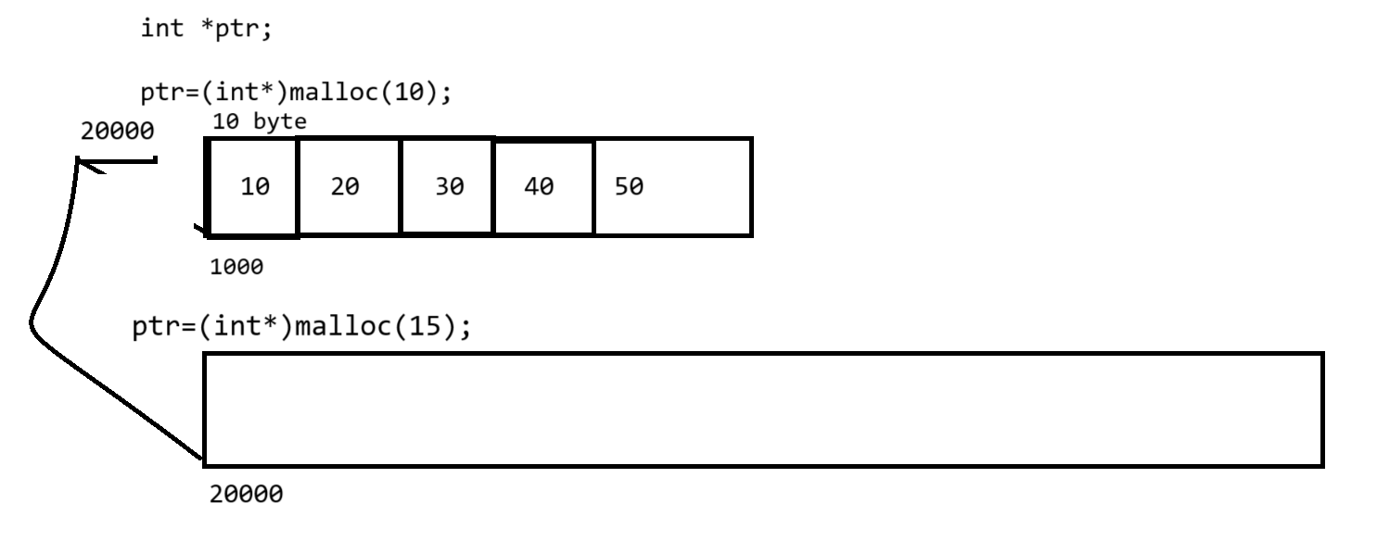
if we think about above code we use two times malloc first statement ptr=(int*)malloc(10) here we allocate 10 byte memory in ram and store 1000 address in ptr and second statement ptr=(int*)malloc(15) here we allocate new memory of size 15 and its address is 20000 so ptr release the previous i.e 1000 and points to new memory whose address is 20000 means previous allocated block not use by pointer so we can say malloc allocate new memory every time.
but if we want to use existing memory with new modifications then we can use realloc functions shown in following diagram

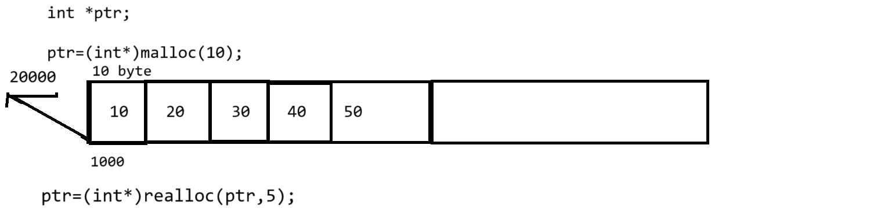
if we think about above code we have ptr we initially we use ptr=(int*)malloc(sizeof(10)) here we allocate 10 byte of memory and assign its address in ptr and again we have statement ptr=(int*)realloc(ptr,5); here realloc not allow new block at run time but expand memory using 5 byte at run time means after realloc we have 15 byte of memory

1. Input number of thali
2. Number thali/10 means required man power
3. allocate memory required man power for storing its data
4. input on spot thali
5. if on spot thali greater than number of thali
means we have some extract thali means we required
some extra ma power
6. extra thali = onspot thali-number of thali
7. extra manpower=extra thali/10
8. reallocate memory for extra man power using realloc
9. show all data from starting to ending .

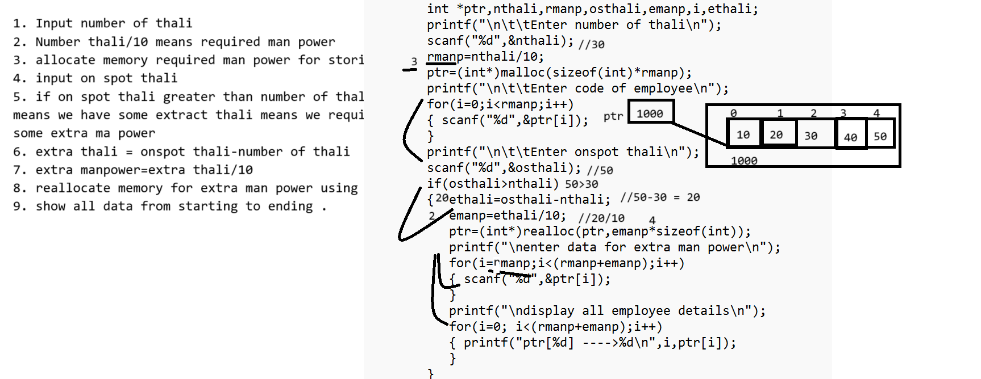
3. Free: free () function is used for release the memory allocated by malloc function
Some time if we allocate memory and if we not required longer time then we can use free () function.

Syntax:
void free(void*) : we can release the memory of any type of pointer allocated by malloc using free function because we have void* as parameter in free function.
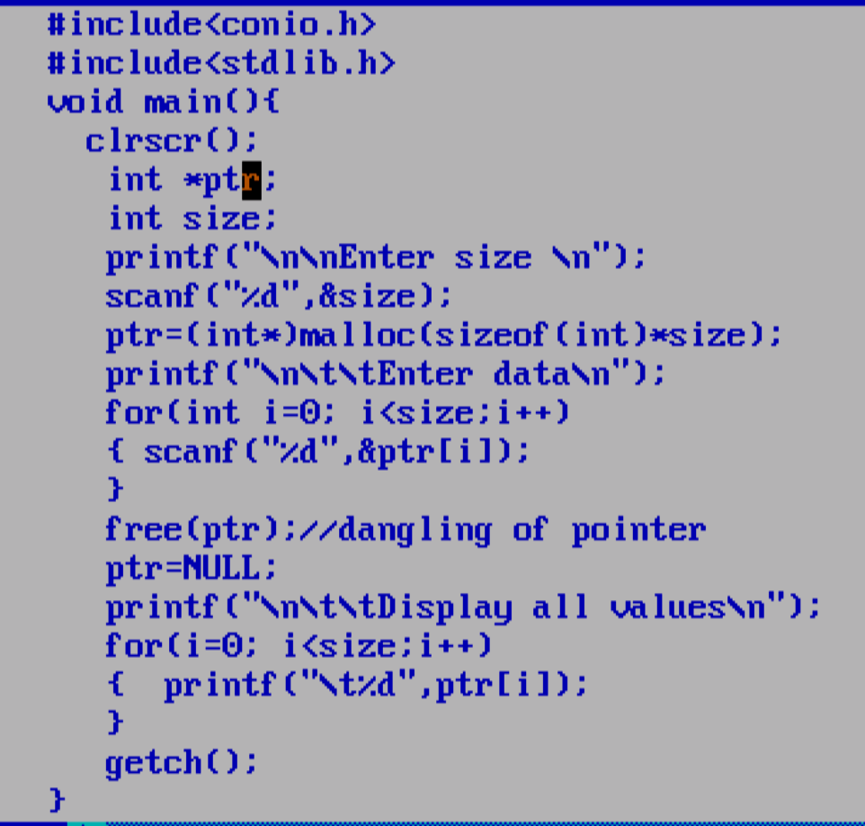

Q. what is NULL pointer?
NULL pointer means pointer not points to any memory address called as null pointer.
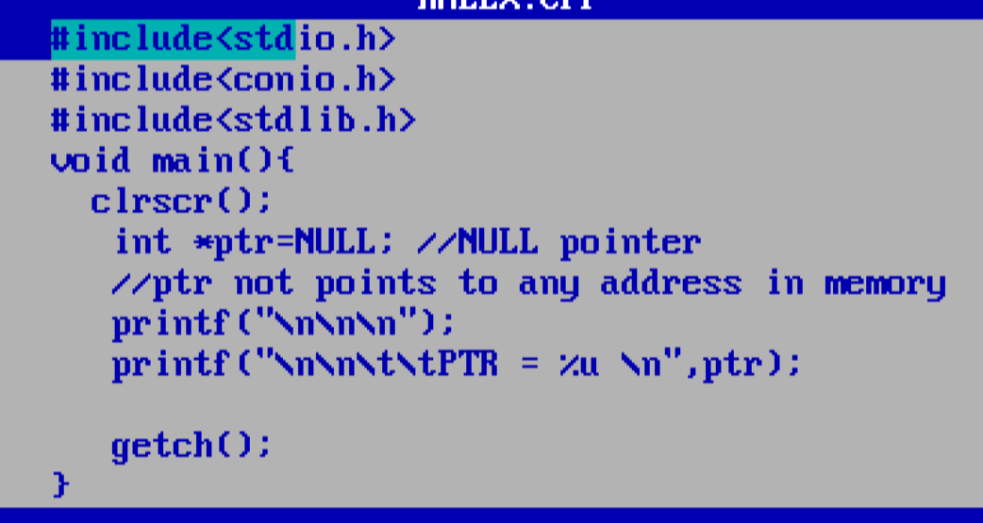
Q. what is wild card pointer?
When we declare pointer and not initialize address in it manually but pointer get random address from memory called as wild card pointer.
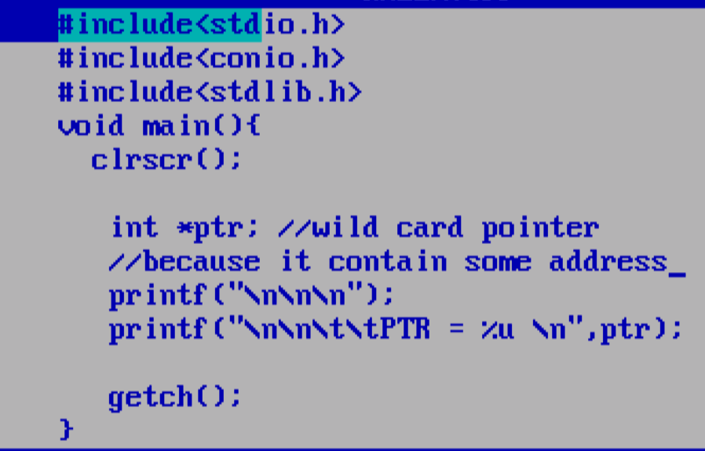

4. Calloc: Calloc stands for continuous memory allocation means calloc also help us to allocate memory dynamically at run time but the major difference between malloc and calloc is malloc allocate only one block at a time and calloc allocate number of blocks of specified size at run time

Syntax: pointer = (void*) calloc (nblock,size);

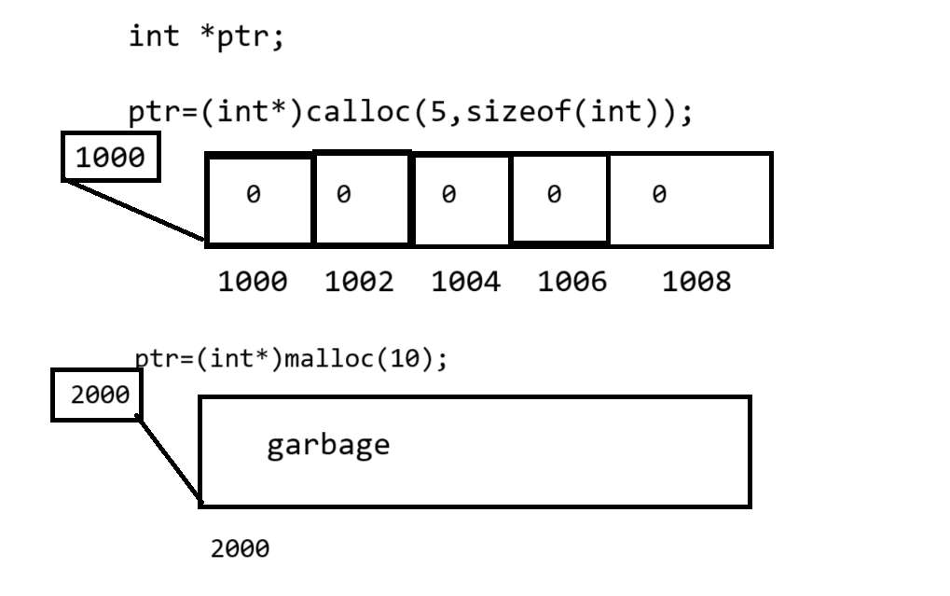
If we think about above diagram we have two functions for dynamic memory allocation one is
Malloc and one is calloc but if we think about calloc then we have 5 block of size 2 continuously but if we think about malloc then we have only one block in memory of size 5 and pointer points to that memory.
#include<stdio.h>
#include<conio.h>
#include<stdlib.h>
void main(){
clrscr();
int *ptr,size;
printf("\n\n\t\tEnter memory limit\n");
scanf("%d",&size);
ptr=(int*)calloc(sizeof(int),size);
printf("\n\t\tEnter values in memory\n");
for(int i=0;i<size;i++)
{ scanf("%d",&ptr[i]);
}
printf("\n\t\tdisplay all values\n");
for(i=0;i<size;i++)
{ printf("\t%d\n",ptr[i]);
}
getch();
}

